


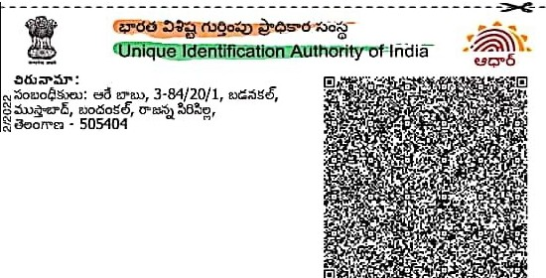Govemmonl ol lndla
-.-.

:> ru90 05'°6
oo
o2?

Unique Identification Authority of India
8 ':J.. / Enrolment No.: 2081/30031/14658
8
To
00 !::J.S
Aare Kavitha C/0: Aare Babu 3·84/20/1 Badanakal Mustabad Bandankal
Rajanna Sircilla Telangana • 505404
9640660387

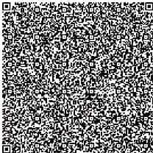
Signa Verilled
f:I',o c!no,,
•a•
Aln'Mllll o, QaclllU.1f'DIG!:1 VfC U

.b.:> e.9Q"O o .s I Your Aadhaar No. :
·-- 9439_7192 3799,_

VID : 9103 5741 2876 8569
><Z
- ur:;r5 l->!l' lbQo;s,,,Lt1 &!:S;(:,t1Jo s-
- ;:»dJ.() "6 ff / u .\,.)§_:i.:io .:>t5 / u 5 dta
rug. !>lio .
- r,;O.'.)Osg-o;:is Q u
INFORMATION
- Aadhaar is a proof of identity, not of citizenship.
- Verify identity using Secure QR Code/ Offline XMU Online Authentication.
- This is electronically generated letter.

- ur:;r5c1,.,.J on- a ZJ"C),) @ &oa.
- :i:iL.'J t1.!.:i>8cti»L.'J ;jJ.11:S .:Se, i())e» n­
aoOel" § ur:;r5 !l:i;(:i:'Jla'S:l.'Jii>t'1lo0.
- .) ;)t!J- !)., t:!6 ;:)or.:16 .tl>Oc:tw 'll a.u6 io :)
UQ"6d "' et5.3=, e o
- .).5:,.ur:;r5 u o.'Jo!J'llo.:So6-!l:iur:;r5 .) .)
!l:i�l��.S c5' e.o.:So6.

- Aadhaar is valid throughout the country.
- Aadhaar helps you avail various Government and non-Government services easily.
- Keep your mobile number & email ID updated in Aadhaar.
- Carry Aadhaar in your smart phone - use mAadhaar App.

1 ( 9' 50_,...:=• -· -
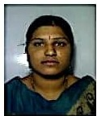
-- CGo'i_ meofiitJooraiaC::=Hl!!'iil!!''"' •-"='--..:-.
e,cl!::J6
Aare lavanya
'":i
ell/DOB: 10/05/1993
FEMALE
o--1Address:
;,;C/0: Aare Babu, 3·84/20/1, Badanakal, Mustabad, Bandankal, Rajanna Sircilla,
iTelangana • 505404
-"
J

9439 7192 3799 9439 7192 3799
1--------"-"""--'-V""ID'-;"-1"0"_..3._..5.._.7.◄=-1=-2--87"6-8-5-6-'-=--- --1*1----'y/ ----"-"""-V-ID': -1=..3......7.41 2=876=85-6 ,"----
...::.,o c;:s00• ...::.,0 n.:>90 a -7 IEsl helpOuldal.gov.ln I s www.uldal.gov.ln

